-- operaciones entre consultas

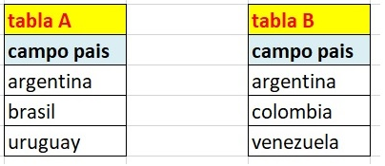

create database operaciones;

use operaciones;

create table A (pais varchar(30));

create table B (pais varchar(30));

insert into A values('Argentina'),('Brasil'),('Uruguay');

insert into B values('Argentina'),('Colombia'),('Venezuela');

-- union

select pais from A

union

select pais from B;

-- union all

select pais from A

union all

select pais from B;

-- intersect

SELECT A.pais

FROM A

WHERE A.pais IN (SELECT B.pais FROM B);

-- except

SELECT DISTINCT \*

FROM A

WHERE NOT EXISTS

(

SELECT NULL

FROM B

WHERE A.pais = b.pais

);

-- Ejercitacion.doc

-- 40. Listar todas las ciudades mencionadas en la base de datos.

select city from publishers

union

select city from authors

union

select city from stores;